About our product:

Our product is an application that used to deal with the image from user’s draft.

Stpe1:

User draw a draft about anything

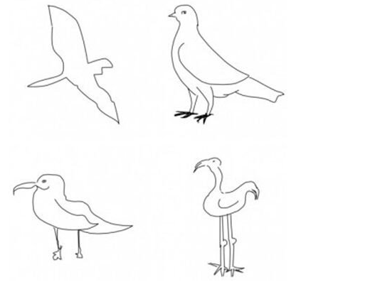

Step 2:

our application will recognize it, know what it is, some times, the draft might not complete like

 our application need to complete it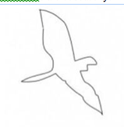

this is for step 1.

Step3:

paint for it to make it to be colorful,

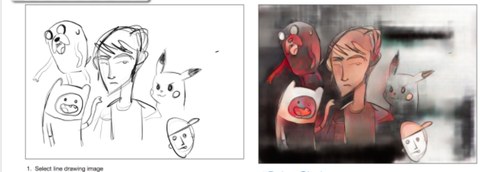

step3:

user choose an famous image like

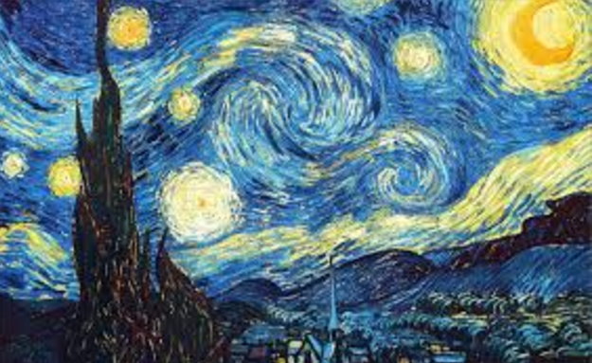

we provide some famous picture to user, they can choose it or they can upload a new picture

and then our application will learn the picture’s style and change the picture provide in step 3’s style to make it match the style of user choose or upload

For the coding part, we will code from step 4 to step 1.